National Centre for Photovoltaic Research and Education (NCPRE)
and
Solar Energy Research Institute for India and the United States (SERIIUS)

Short-Term CEP Course
On
PV Module Reliability
April 3-4, 2014

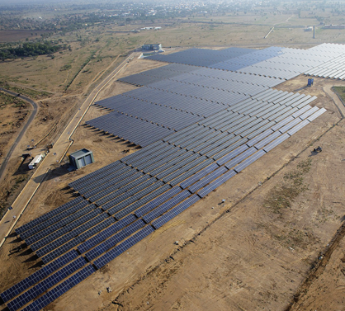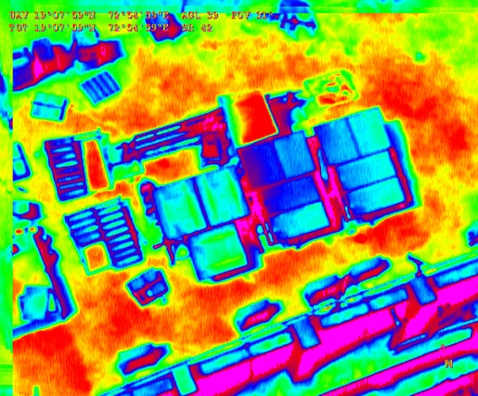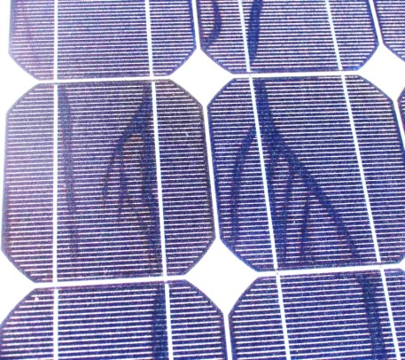

Venue:
Seminar Hall, Room No-22, 2ndFloor
Victor Menezes Convention Centre (VMCC)
Indian Institute of Technology Bombay



Introduction:
The Continuing Education Programme of the Indian Institute of Technology Bombay, the National Centre for Photovoltaic Education and Research (NCPRE) and the Solar Energy Research Institute for India and the United States (SERIIUS) are jointly organizing a two-day short course and workshop on “PV Module Reliability”.
With the unfolding of the Jawaharlal Nehru National Solar Mission (JNNSM), as well as several state-level solar energy programmes, there has been a great deal of activity in setting up solar PV plants and installations in various parts of India. One concern which has been felt is the reliability of the PV modules of various technologies in the different climatic zones of India. This short course and workshop, with presentations by experts in PV module reliability from USA and India, will address these issues.
Speakers for the short course / workshop include: Dr. Larry Kazmerski (NREL, USA), Dr. G. Tamizhmani (Arizona State University, USA), Dr. Nick Bosco (NREL, USA), Dr Neelkanth Dhere (Florida Solar Energy Center, USA), Dr. O. S. Sastry (SEC, India), Dr. Anil Kottantharayil (NCPRE, IIT Bombay, India) and Dr. Liang Ji (UL, USA).
The workshop would also be an excellent opportunity for networking with your peers from industry, research labs and academia.

Target Participants:
- PV plant developers
- PV module manufacturers
- PV installers, financial institutions
- PV certifying agencies
- Researchers in PV technology, modules and systems

Course Contents:
The tentative list of topics covered during this course will be:
- Introduction to PV Modules
- Performance Characterizations of Commercial PV Modules
- Degradation and Failures in Crystalline Silicon PV Modules in Power Plants
- Failure in Thin Film Modules
- Standards and Certification of PV Modules
- Thermal Imaging, Electroluminescence and other Diagnostic Tools
- Thermal and Mechanical Cycling for Module Lifetime Prediction
- Degradation and Failures of PV Modules in Accelerated Testing
- Effect of Dust on Performance / Reliability and Mitigation Strategies
- PV Module Performance Data and All-India PV Module Survey
- Field Experience in India and Panel Discussion

Eligibility:
A participant must have a minimum academic qualification of science or engineering. Participants may be from industry, individual or academic/research institutions. Students are not eligible for the program.

Dates:
April 3-4, 2014.
Registration Details:
Participants are required to confirm their registration by sending the completed Registration Form, along with the fees to Smita Bhattacharjee (see details below).
The fees must be paid by demand draft in favour of “Registrar IIT Bombay - CEP Account”.

For online payment the RTGS details has been mentioned below:

RTGS Transfer Details:

Bank Details
Name of the Bank : State Bank of India
Bank Branch : IIT Powai
Address : A.S. Marg, Powai (IIT Main Gate), Mumbai-400 076 India.
Phone with code : +91-22-25728555

Bank Code and A/c No.
Beneficiary : Registrar, IIT Bombay
Bank A/c No. : 10725729128
Account Type : CURRENT
MICR Code : 400002034
IFSC Code : SBIN0001109
SWIFT code : SBININBB519
Purpose / Reference : CEP course
Email ID : cep@iitb.ac.in

Fee Structure: Rs. 12,000.00

A confirmation email will be sent after we receive the demand draft. If you do not hear from us for over 7 days, please track your courier. Please drop us an email at ncpre@iitb.ac.in only if the post has reached us and you have not heard from us. Your registration is complete only after we receive your demand draft and the registration form.

Course Coordinators:
Prof. J. Vasi & Prof. Anil Kottantharayil
Department of Electrical Engineering
Indian Institute of Technology Bombay
Powai, Mumbai-400 076

Deadline for submitting the Registration Form and Fees is 24th March, 2013.

Kindly send the application and demand draft by speed post/courier to the address mentioned below:

Mrs. Smita Bhattacharjee
Microelectronic office
Electrical Engineering (Annex Bldg)
Room No-313, 2nd Floor
IIT Bombay, Powai, Mumbai-400076
Email: smita98@iitb.ac.in
Contact No: 02225764476

Accommodation Details:

Accommodation is available in the IITB student hostel, and in hotels close to IITB. We have arranged special rates at hotels as listed below, for which participants may make payment directly to the hotels. Please find the table below with details of the tariffs of different hotels. You can directly contact the concerned person whose name and number is given in the table. Please mention the name of course (“PV Module Reliability”) and give the reference of Mr. Dabholkar (who is in charge of accommodation for IITB).

Sl.No. | Type of accommodation | Contact Person | Contact Number | Tariff for single occupancy | Tariff for double occupancy
- 1. | Student Hostel (only 12 rooms available) | Bharat Pawar | bharatpawar5483@gmail.com  08108594844/09821181944 | - | 185/-
- 2. | Hotel Residence | Naveen Somasundaran | ssm2@ramadapowai.com  09967572917 | 4500+tax | 5000+tax
- 3. | Hotel Ramada | Naveen Somasundaran | ssm2@ramadapowai.com  09967572917 | 6000+tax | 6500+tax
- 4. | Hotel Beatle | Anuj Mishra | anuj.mishra@beatlehotels.com  09833630084 | 4500+tax | 5000+tax
- 5. | Hotel Rodas | Garfield Soares | Garfield.soares@meluhafernhotel.com  022-42611111 | 5500+tax | 6000+tax
- 6. | Hotel Meluha | Garfield Soares | Garfield.soares@meluhafernhotel.com  022-42611111 | 8000+tax | 9000+tax

More details: http://www.ncpre.iitb.ac.in/events.php

